**In-House Order Processing Automation**

Contents

Overview 1

Key Features: 2

System Requirements 2

SharePoint Fields 2

Process Flow 4

Step 1: Order Creation 5

Step 2: Department VP Approval 5

Step 3: Finance Manager Review (if DAR Funded) 5

Step 4: Finance VP Approval 6

Step 5: Order Creation in System 6

Step 6: Notification to Requestor 6

Step 7: Approval Reminder (If pending) 6

Automation Workflow 7

1. Power Automate Trigger: 7

2. Actions Performed by Power Automate: 7

3. Approval Flow Details: 7

SharePoint List Configuration 8

Fields in SharePoint List: 8

Appendices 9

A. Troubleshooting Common Issues 9

B. Contact Information 9

# Overview

This document describes the automated order processing workflow implemented using SharePoint and Power Automate. The system automates the approval process, ensures timely approvals, and facilitates the creation of orders in the system. The workflow includes order initiation, multi-level approval, order creation, and automated notifications to the requestor.

## Key Features:

* **Approval Workflow**: Includes approvals from Department VP, Finance Manager (for DAR funded orders), and Finance VP.
* **Order Creation**: Once all approvals are received, the order is processed and entered into the system.
* **Notifications**: Automated emails to the requestor with order confirmation and status updates.
* **Reminder Mechanism**: Sends reminders if approvals are delayed beyond three days.

# System Requirements

1. **SharePoint**: Used for storing and tracking order data.
2. **Power Automate**: Automates the approval workflow and email notifications.
3. **Email Integration**: Sends emails for approvals and notifications at key steps.

# SharePoint Fields

The following SharePoint fields track the order’s details and its approval status:

|  |  |
| --- | --- |
| Field Name | Description |
| Title | The title or name of the order. |
| Cost Center | The cost center associated with the order. |
| Business Justification | A brief description explaining why the order is being requested. |
| Delivery Address and Attention To | The delivery address and the person to whom the order should be directed. |
| Status | The current status of the order (e.g., **New**, **Pending Dept Approval**, **Pending Approval for DAR**, **Pending Finance VP Approval**, **Quiz to Requestor**, **Processed**, **Rejected**). |
| SKU and Per Unit Cost | The SKU and per unit cost of the ordered product. |
| Total Cost | The total cost of the order (calculated as SKU * Per Unit Cost). |
| DAR Funded (Yes/No) | Indicates whether the order is DAR funded. |
| DAR Account Number | The DAR account number assigned by the Finance Manager (to be filled by Finance). |
| Order Number from In-house | The order number assigned by the In-house team once the order is processed in the system. |
| Approval Info from Dept VP | The approval details from the Department VP once the order is approved. |
| Approval Info from Finance | The approval details from the Finance VP once the order is approved. |
| Attachment(s) if Any | Any attachments related to the order, such as quotes, invoices, etc. |
| Department VP | A selection field where the relevant Department VP is chosen for approval. |
| Finance VP | A selection field where the relevant Finance VP is chosen for approval. |

# Process Flow

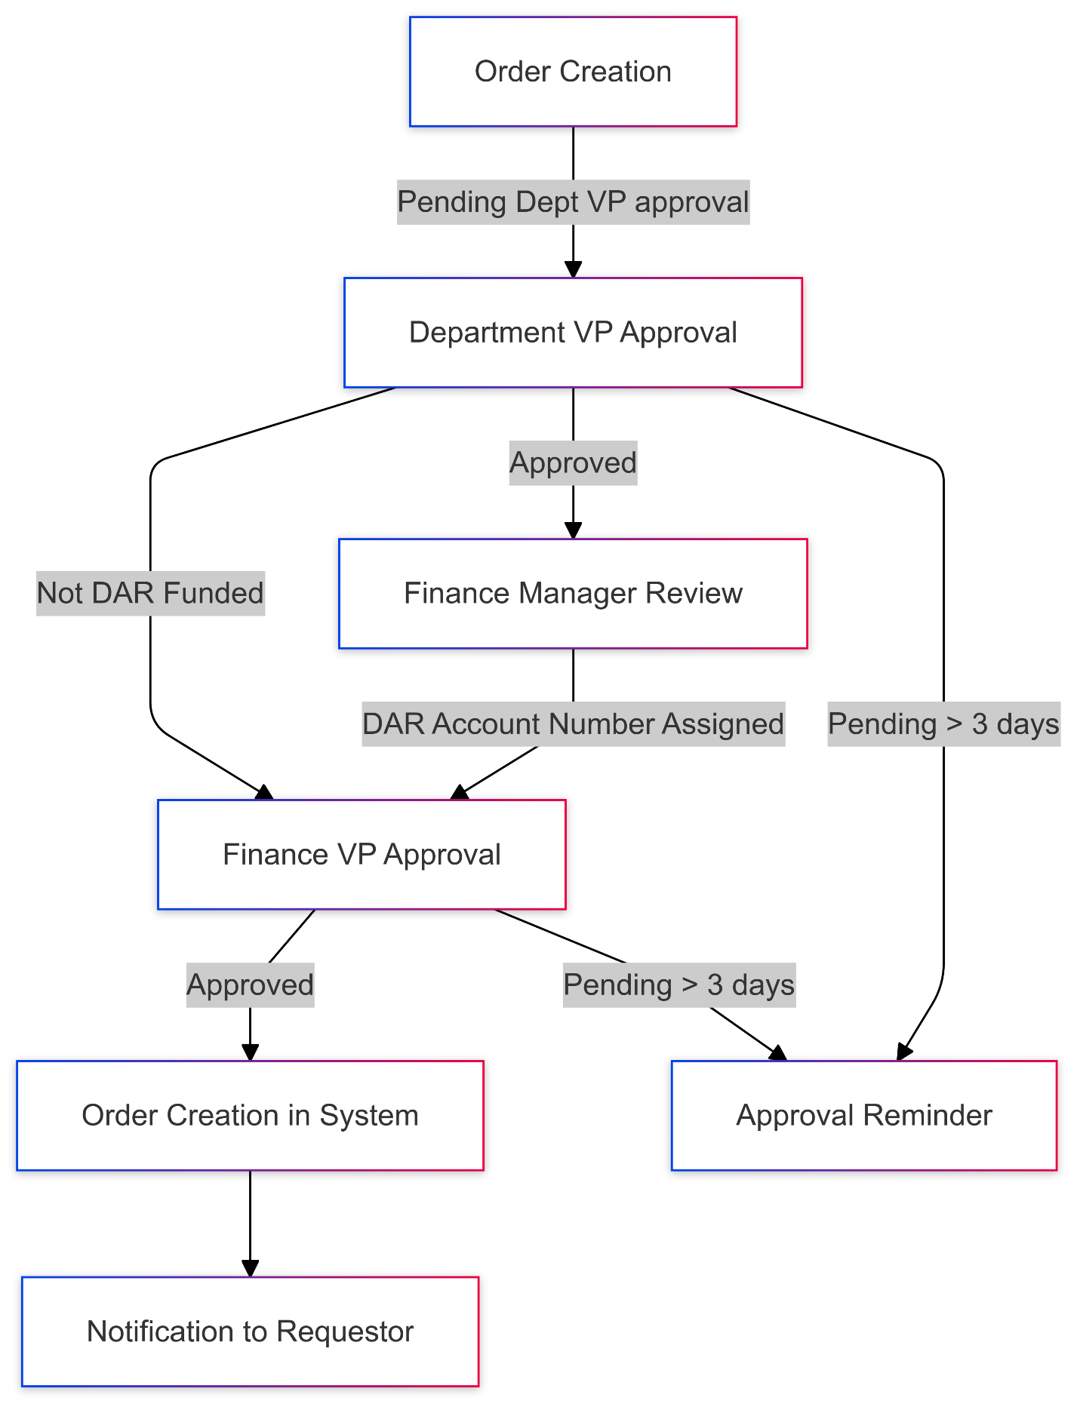

## Step 1: Order Creation

1. **User Action**: The user creates an order in the SharePoint list and provides the following details:
   * **Title**: A unique order identifier.
   * **Cost Center**: The department or business unit requesting the order.
   * **Business Justification**: A brief explanation for the order.
   * **Delivery Address and Attention To**: Specifies the delivery location and the person to receive the order.
   * **SKU and Per Unit Cost**: The product SKU and price.
   * **Total Cost**: Calculated as SKU * Per Unit Cost.
   * **DAR Funded**: Indicates whether the order is DAR funded (Yes/No).
   * **Department VP**: The relevant **Department VP** is selected from a predefined list.
   * **Finance VP**: The relevant **Finance VP** is selected from a predefined list.
2. Once the item is created, the user sets the **Status** to **"Pending Dept VP approval"**. This triggers the automated approval process.

## Step 2: Department VP Approval

1. **Power Automate Action**: The workflow is triggered when the **Status** field is updated to **"Pending Dept VP approval"**.
   * Power Automate sends an approval request email to the **Department VP** selected in the **Department VP** field. The email includes the order details and a link to approve or reject the order.
2. Once the **Department VP** approves the order, Power Automate updates the **Approval Info from Dept VP** field in SharePoint and changes the **Status** to **"Pending Finance VP approval"**.
   * If the order is **DAR funded**, it proceeds to the next step. If not, it skips to the Finance VP approval.

## Step 3: Finance Manager Review (if DAR Funded)

1. If the order is **DAR funded**, Power Automate sends an email to the **Finance Manager**, requesting them to review the order and assign a **DAR Account Number**.
2. The **Finance Manager** reviews the order and updates the **DAR Account Number** field in SharePoint.
3. Once the **DAR Account Number** is filled, the **Status** changes to **"Pending Finance VP approval"**.

## Step 4: Finance VP Approval

1. **Power Automate Action**: Power Automate sends an approval request email to the **Finance VP** selected in the **Finance VP** field. The email contains all order details, including the **DAR Account Number** (if applicable), and a link for approval.
2. Once the **Finance VP** approves the order, the **Approval Info from Finance** field is updated, and the **Status** changes to **"Approved"**.
3. Power Automate then sends an email to the **In-house Team** with all the approval information and order details to proceed with creating the order in the system.

## Step 5: Order Creation in System

1. The **In-house Team** receives the email with the approval details and proceeds to create the order in the system.
2. The **Order Number from In-house** field is populated with the assigned order number once the order is processed in the system.
3. Once the order number is added, the **Status** is updated to **"Processed"**.

## Step 6: Notification to Requestor

1. **Email Notification**: The requestor receives an email containing the **Order Number** assigned by the In-house team and any other relevant details, confirming that the order has been processed.
2. The requestor can use the order number for reference when inquiring about the order or checking its progress.

## Step 7: Approval Reminder (If pending)

1. If any approval step is pending for more than three (3) days, Power Automate automatically sends a reminder email to the respective approver (either the **Department VP** or the **Finance VP**). The reminder email includes the approval link and encourages the approver to take action.

# Automation Workflow

### 1. Power Automate Trigger:

* The workflow is triggered whenever a new item is created or when the **Status** field is updated in the SharePoint list (e.g., from **Pending Dept VP approval** to **Pending Finance VP approval**, or from **Pending Finance VP approval** to **Processed**).

### 2. Actions Performed by Power Automate:

* **Send Approval Emails**: Power Automate sends automated approval emails to the **Department VP** and **Finance VP**, based on the selection in the **Department VP** and **Finance VP** fields.
* **Update Status in SharePoint**: The **Status** field is updated in SharePoint after each approval step.
* **Send Reminder Emails**: If an approval is pending for more than three days, Power Automate sends reminder emails to the respective approver.
* **Send Order Confirmation Email to Requestor**: Once the order has been processed by the In-house team, Power Automate sends an email to the requestor with the **Order Number**.

### 3. Approval Flow Details:

* **Dept VP Approval**:
  + The selected **Department VP** receives an approval email with an **approve/reject** option.
  + Once approved, the **Approval Info from Dept VP** field is updated, and the status changes to **"Pending Finance VP approval"**.
* **Finance Manager Review (if DAR Funded)**:
  + The Finance Manager assigns the **DAR Account Number** in the SharePoint list.
  + Once assigned, the **Status** changes to **"Pending Finance VP approval"**.
* **Finance VP Approval**:
  + The selected **Finance VP** receives an email for final approval.
  + After approval, the **Approval Info from Finance** field is updated, and the **Status** changes to **"Approved"**.
* **In-House Team Notification**:
  + After Finance VP approval, the In-house team receives an email to proceed with creating the order in the system.
  + Once the order is processed, the **Order Number from In-house** is added, and the **Status** is updated to **"Processed"**.

# SharePoint List Configuration

### Fields in SharePoint List:

1. **Title**: A unique identifier for the order.
2. **Cost Center**: The department or business unit requesting the order.
3. **Business Justification**: A description of the reason for the order.
4. **Delivery Address and Attention To**: The delivery destination and the recipient of the order.
5. **Status**: The current status of the order (e.g., **New**, **Pending Dept Approval**, **Pending Finance VP Approval**, **Processed**, etc.).
6. **SKU and Per Unit Cost**: The SKU and per unit cost of the ordered product.
7. **Total Cost**: The calculated total cost of the order.
8. **DAR Funded**: Indicates if the order is DAR funded (Yes/No).
9. **DAR Account Number**: The DAR account number assigned by Finance (filled by Finance Manager).
10. **Order Number from In-house**: The order number assigned by the In-house team after the order is processed.
11. **Approval Info from Dept VP**: Contains the approval information from the Department VP.
12. **Approval Info from Finance**: Contains the approval information from the Finance VP.
13. **Attachment(s) if Any**: Any attachments related to the order.
14. **Department VP**: A selection field for the relevant **Department VP**.
15. **Finance VP**: A selection field for the relevant **Finance VP**.

# Appendices

### A. Troubleshooting Common Issues

* **Issue**: Approval emails not being sent to the right person.
  + **Solution**: Verify the correct **Department VP** and **Finance VP** are selected in the SharePoint list and check if the email addresses in Power Automate are accurate.
* **Issue**: Requestor not receiving the order confirmation email.
  + **Solution**: Ensure the **Status** field is updated correctly to **"Processed"** and confirm from support team that Power Automate is triggered for the final email to the requestor.

## B. Contact Information

For support, contact the IT support team at [hamad.ullah@zones.com](mailto:hamad.ullah@zones.com)